1. Introduction
   1. Background

Australia has many towns. Although Australia has a quite big size of continent, population is not that big, so people would gather in town for living, and some places are simply just a piece of land. There are various states in Australia, and Queensland state is the focus of this analysis.

* 1. Problem

In this analysis, we want to identify what’s the density between this towns in QLD state Australia, and want to know what is the segmentation based on geographical information.

1. Data description

We have a list of data that showing up the list of suburbs in QLD state, each row of data has identified latitude and longitude, some towns might share same postcode but they still have different geographical data. See below as sample data. information.

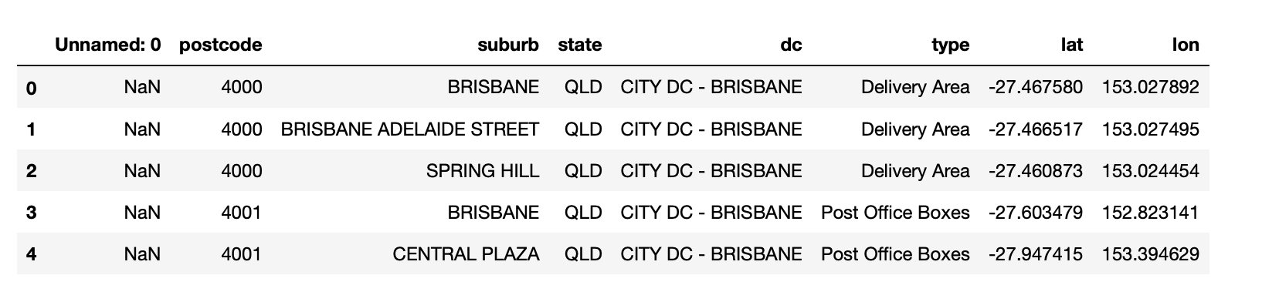

1. Analysis.

According to latitude and longitude data we map the data point on geo map.

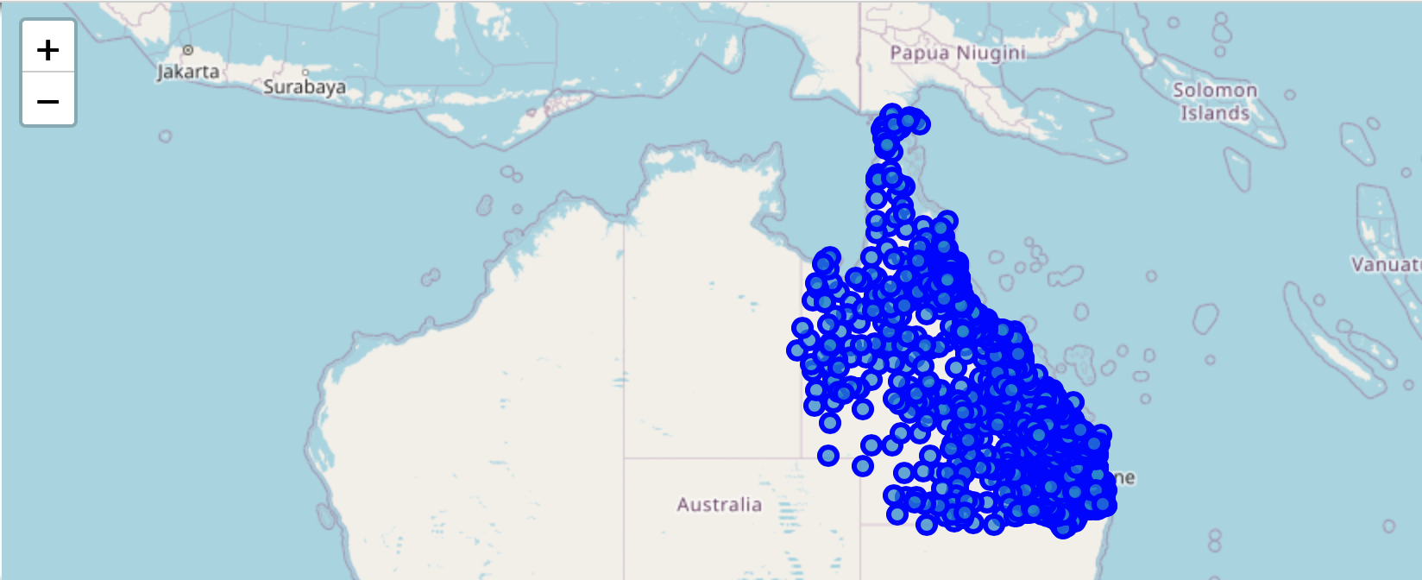

It can be enlarged to see the specific location of each town. Brisbane and Gold Coast are the densest area in Queensland state.

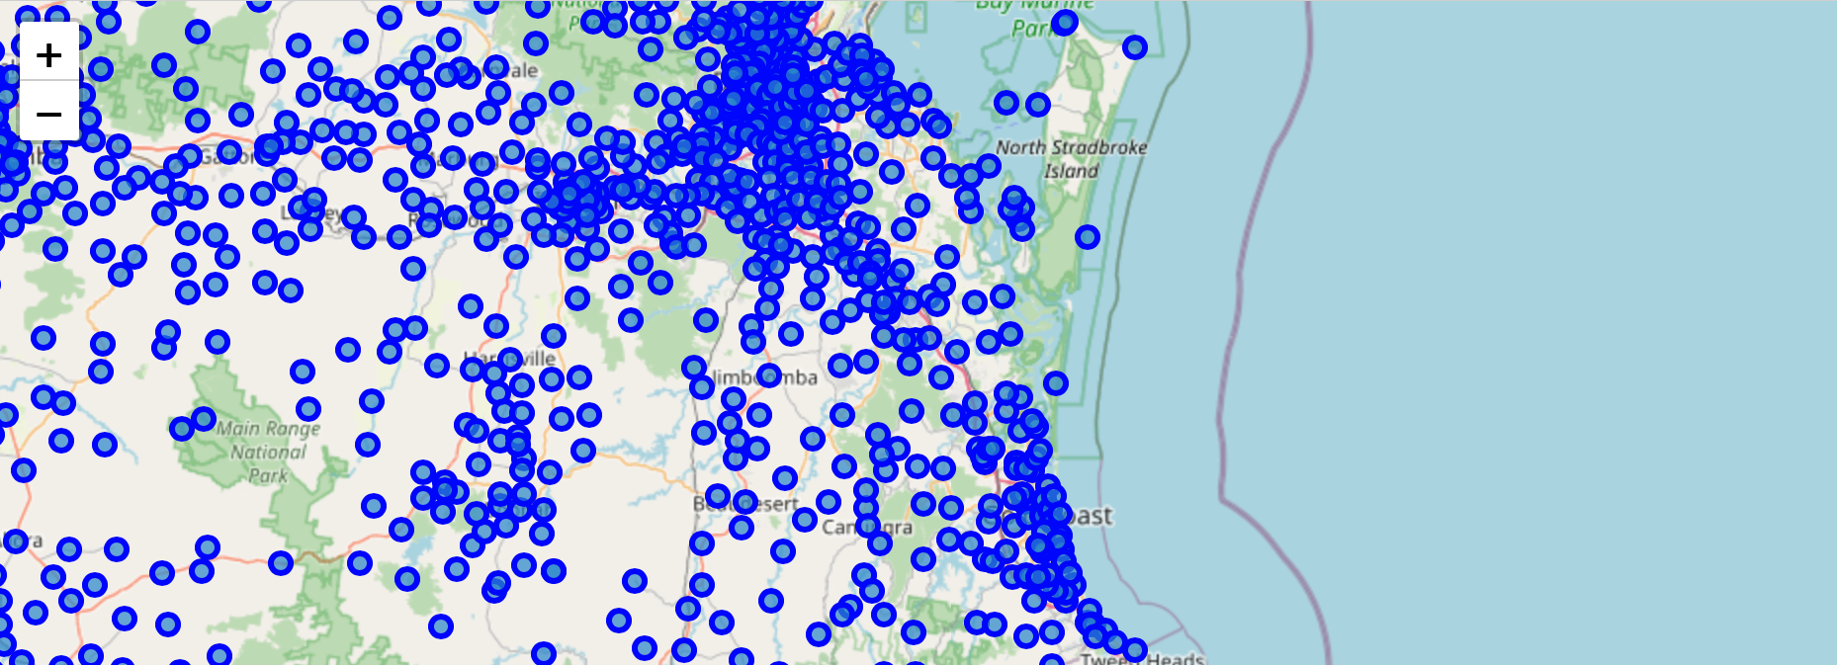

We actually do not know the number of clusters. There are several methods to select k that depends on the domain knowledge and rule of thumbs. Elbow method is one of the robust one used to find out the optimal number of clusters.

The graph shows us the 2 is the best value as after two the curve is flatten.

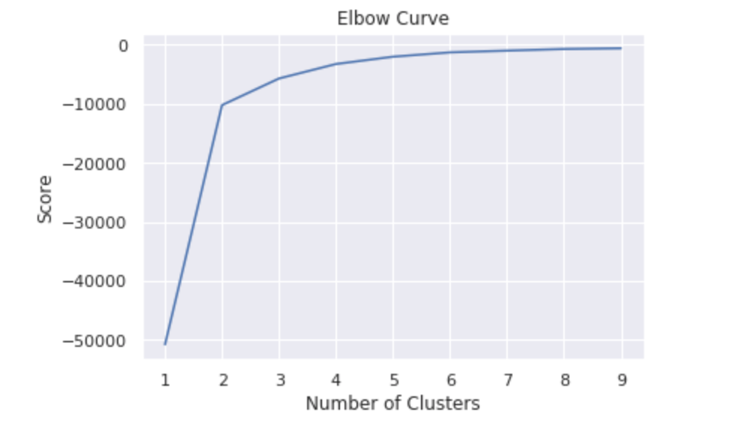

Thus, we use k=2 to continue our analysis. Through scatter plot we can segment the clustering into three big groups according to density.

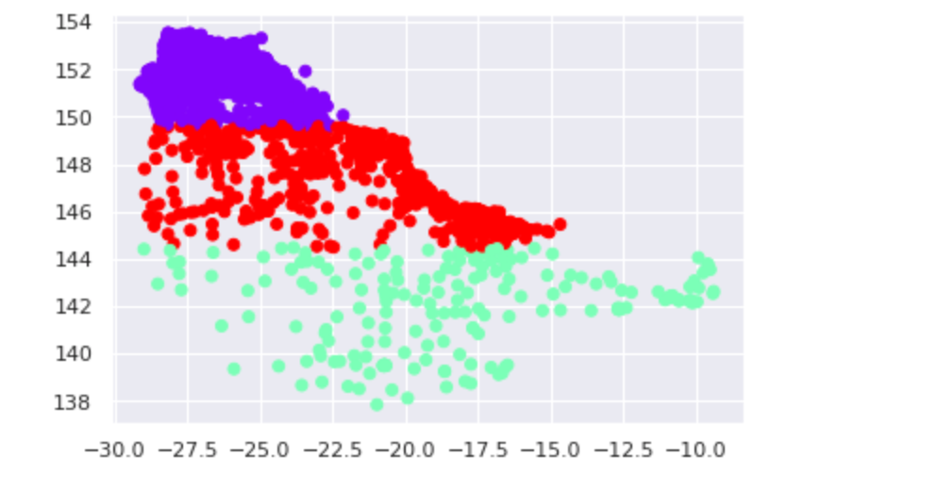

1. Conclusion

For those town in Queensland state, we can see there are three big groups of them based on locations. In the range of longitude 150-154, latitude -28-25, has the highest number of towns located in this range of location.